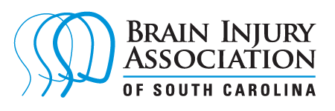
2024 Walk, Run, and Roll for Brain Injury Awareness
Sponsorship Information
The Brain Injury Association of SC (BIASC) will be hosting a statewide Walk, Run, and Roll the week of March 17-23, 2024, for Brain Injury Awareness Month. This event will promote awareness about brain injury and raise funds to support the efforts of the BIASC. The BIASC’s mission is “creating a better future through brain injury prevention, research, education and advocacy.” Learn more about the organization at https://www.biaofsc.com/
A sponsorship is $250 dollars and includes:
- Your company’s name/logo on the event website
- Your company’s name/logo on the event t-shirt
- Your company’s name/logo on marketing materials
- Mention of your company in social media posts leading up to the event
BIASC is a 501(c)(3) not-for-profit organization so your donation is tax-deductible.

Yes, sign me up to sponsor the event!
Company Name: ___________________________________________
Contact Person: ____________________________________________
Phone #: __________________________________________________
Address: __________________________________________________
Email: ____________________________________________________
Please email a vector file (SVG) of your company logo by February 12 to
adminassist@biaofsc.com

